**Computer networks laboratory week 8**

**Name: Pranav R. Hegde SRN: PES1UG19CS343 Section: F1**

**STEP 1:** Assigning IP Addresses to each computer At Ha:

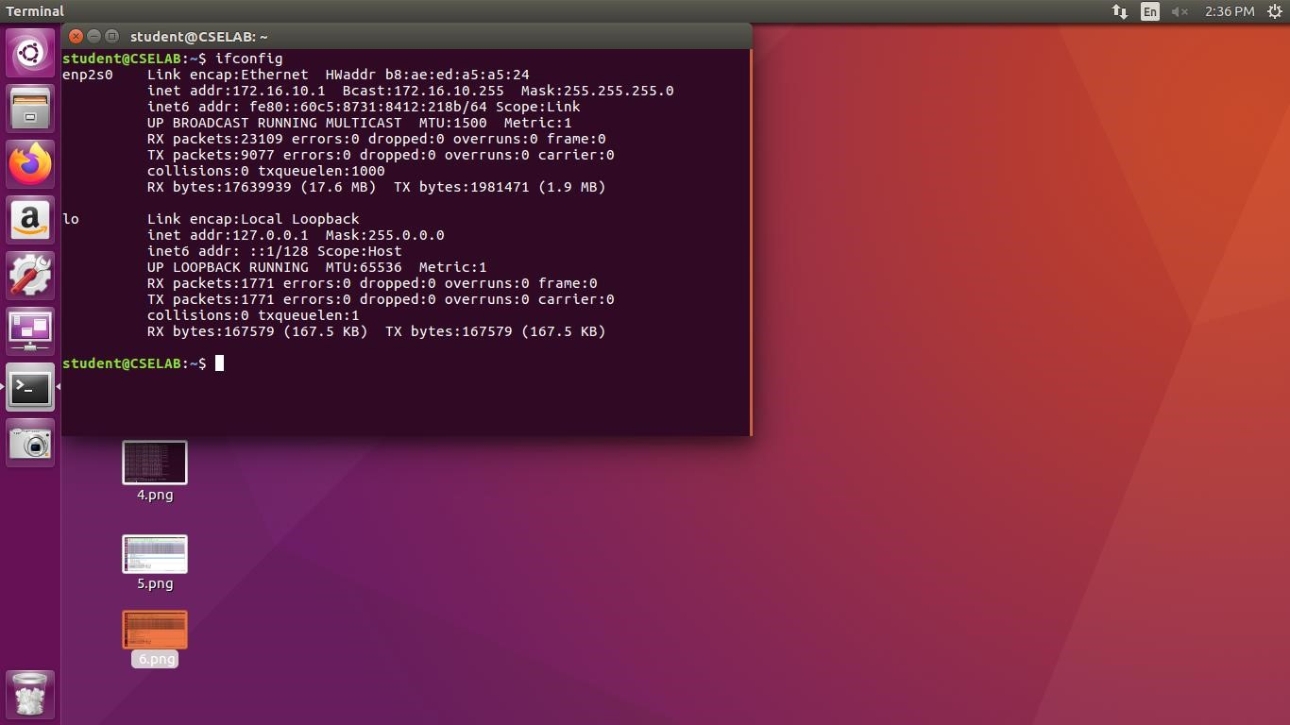

At Hb:

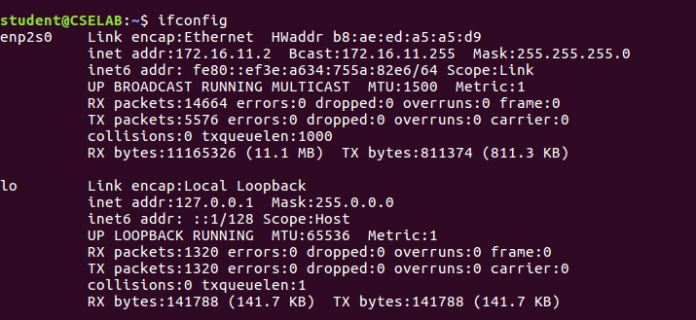

At R1:

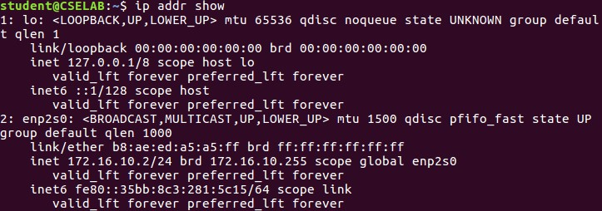

At R2:

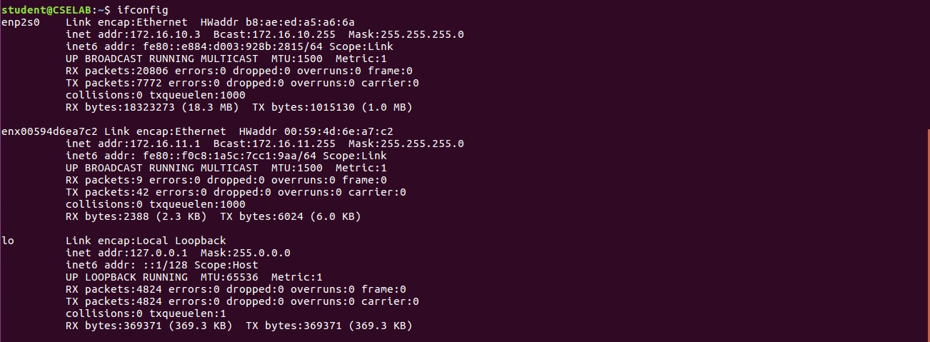

Disabling accepting the ICMP redirect packets

At Ha:

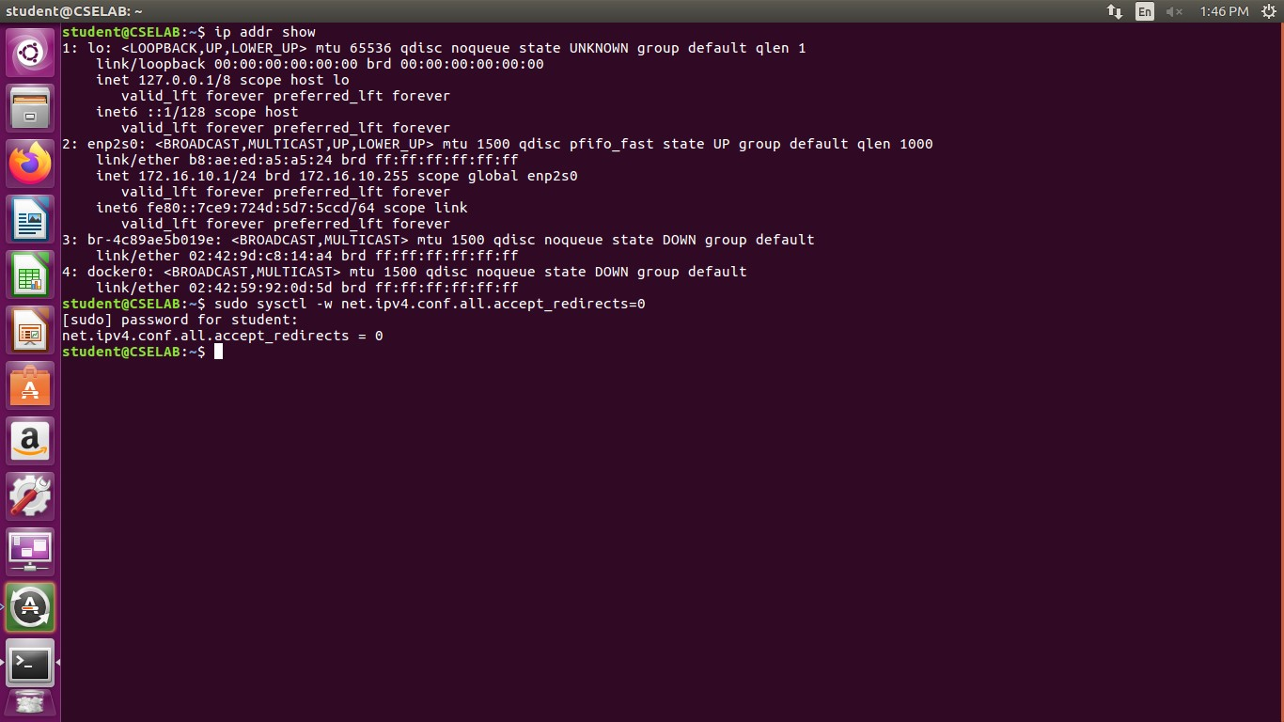

At Hb:

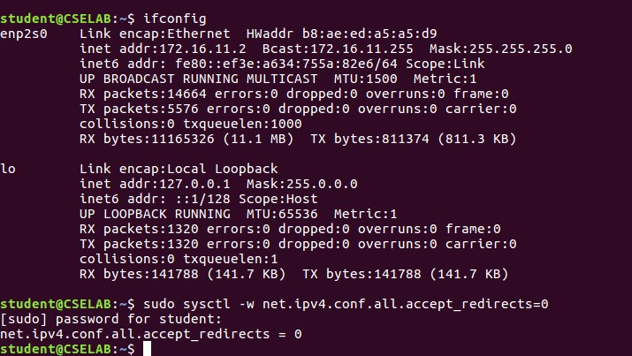

**STEP 2:** Converting two systems into routers R1 and R2

At R1:

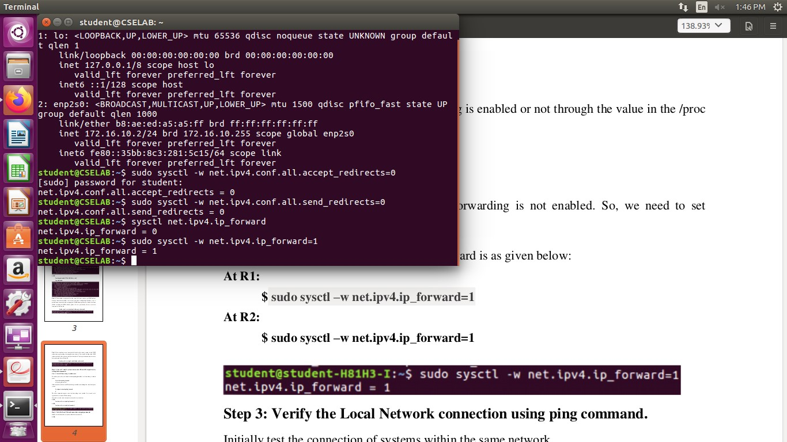

At R2:

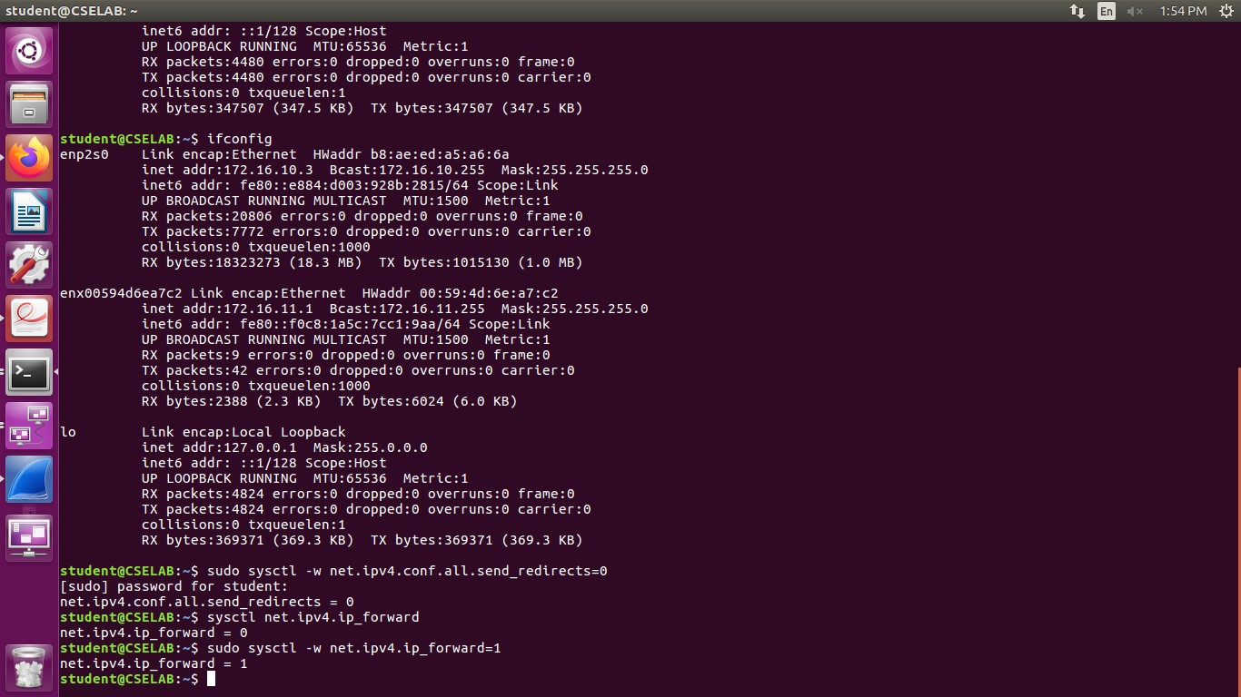

**STEP 3:** Verifying the local network using ping command

At Ha:

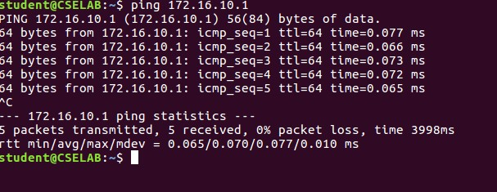

At Hb:

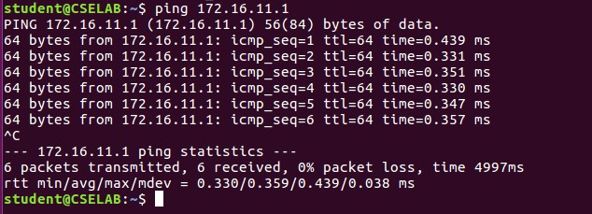

**STEP 4:** Inserting routing table entries to direct ipv4 packets

At Ha:

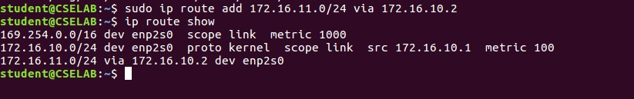

At R1:

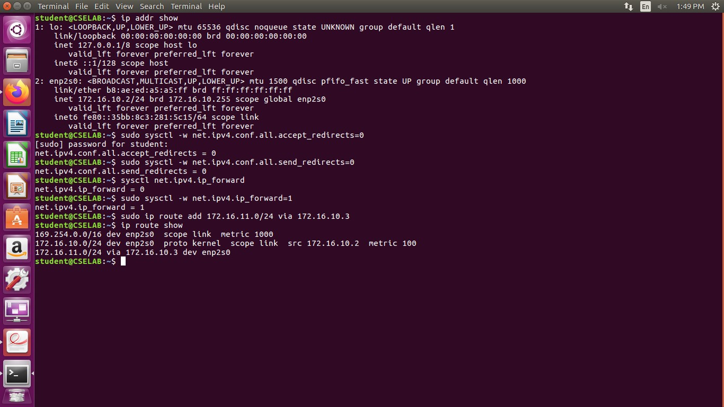

At Hb:

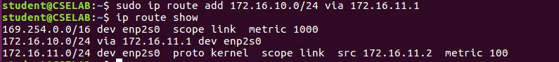

**STEP 5:** Capturing packets on Wireshark

Pinging Hb from Ha:

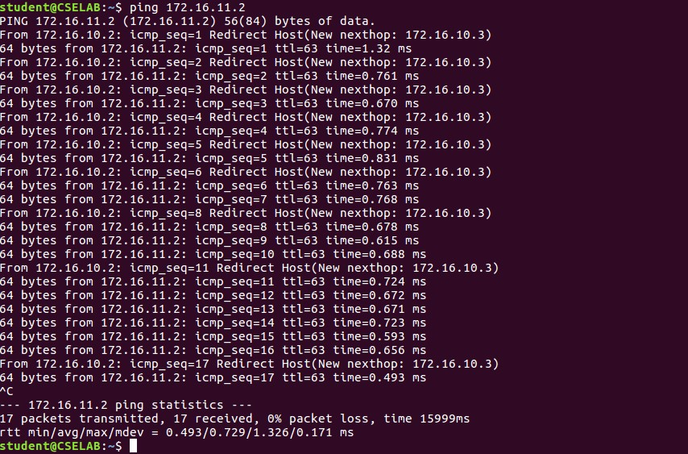

Capturing packets at Ha:

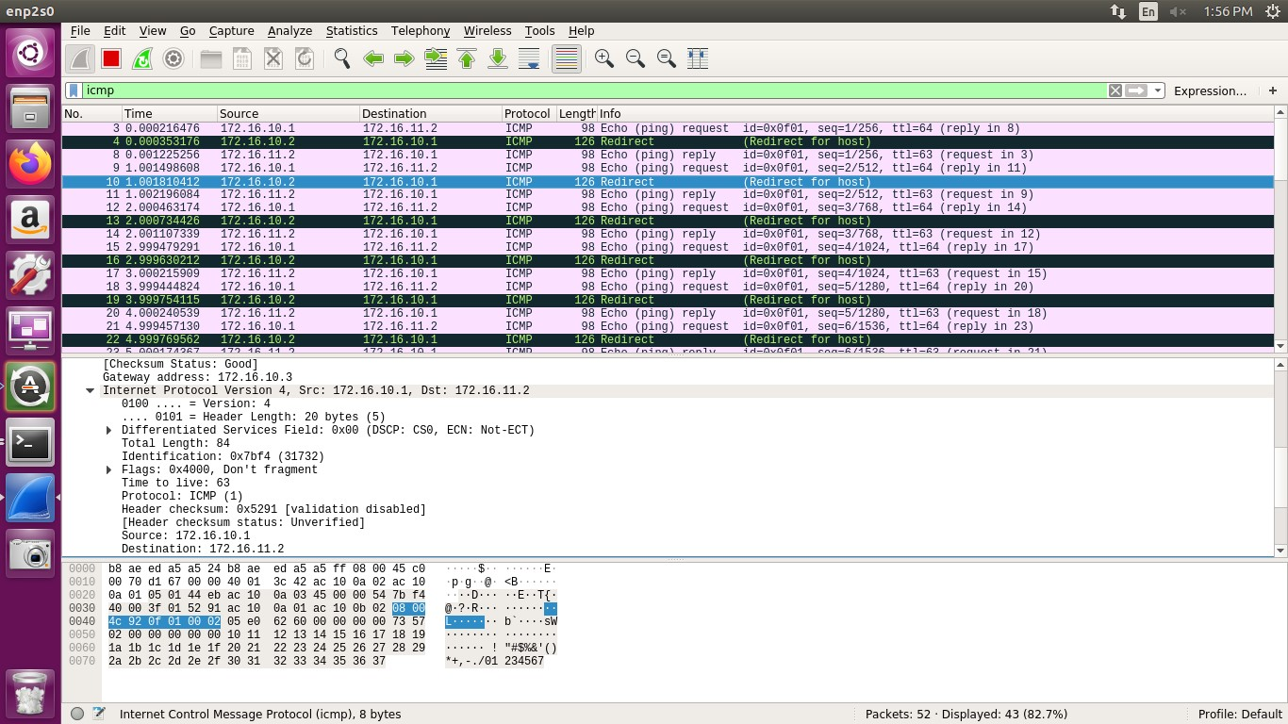

Capturing packets at R1:

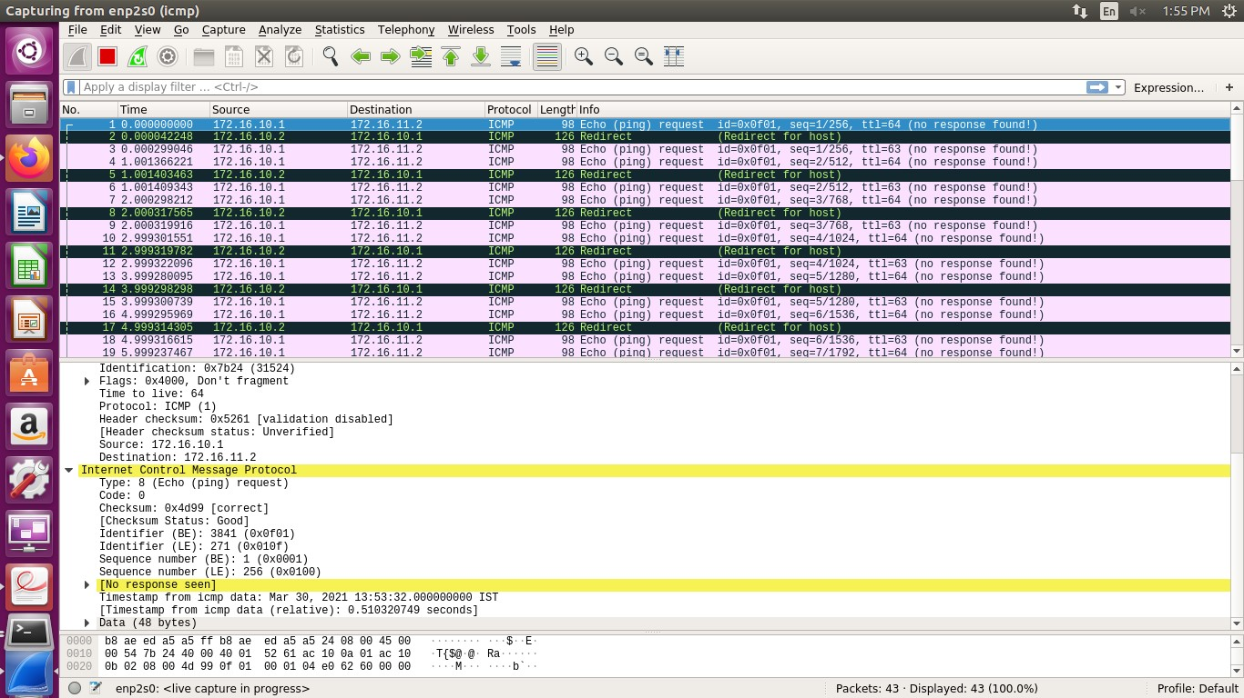

Capturing packets at R2:

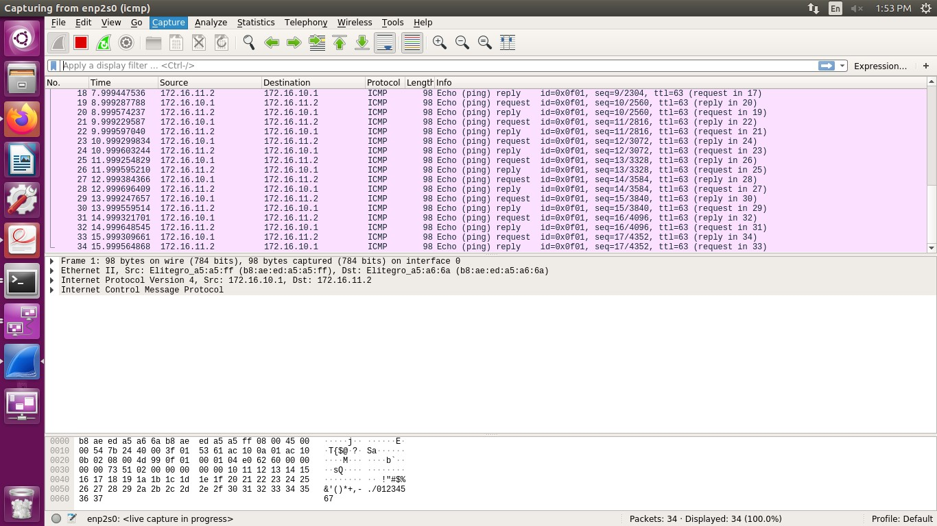

Capturing packets at Hb:

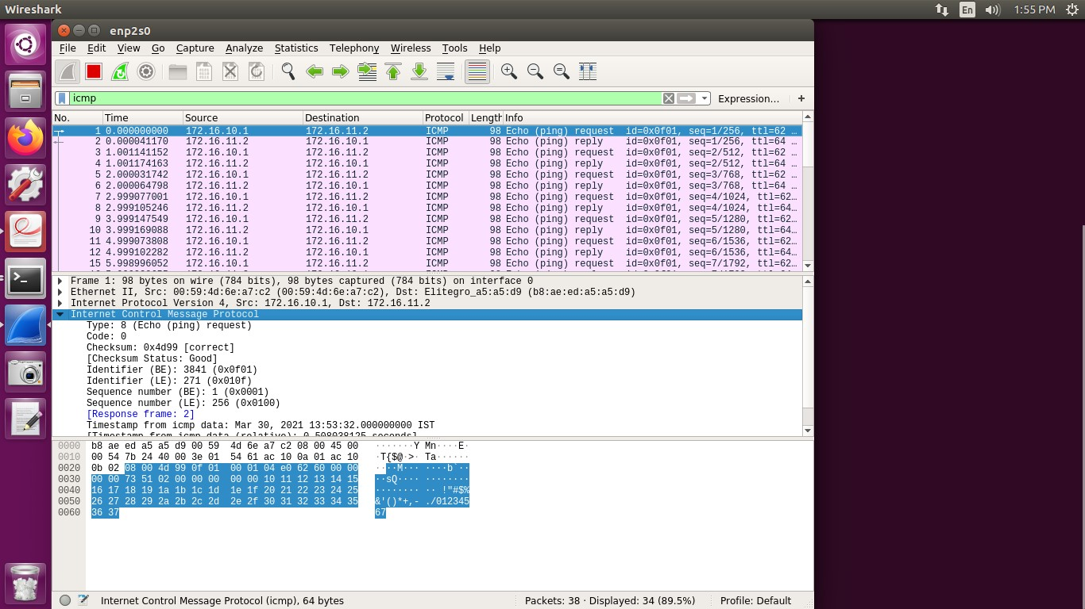

**STEP 6:** Checking each system neighbours to verify the connection At Ha:

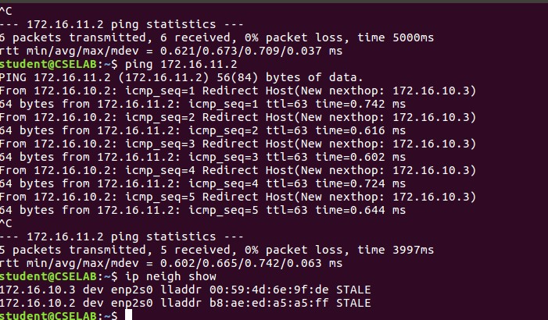

At R1:

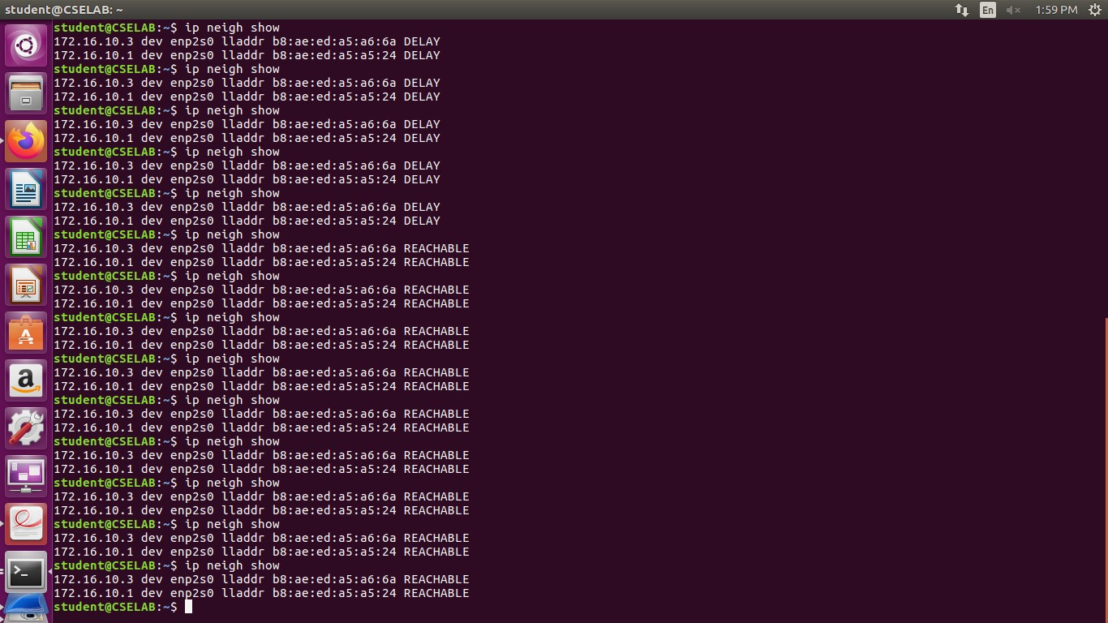

At R2:

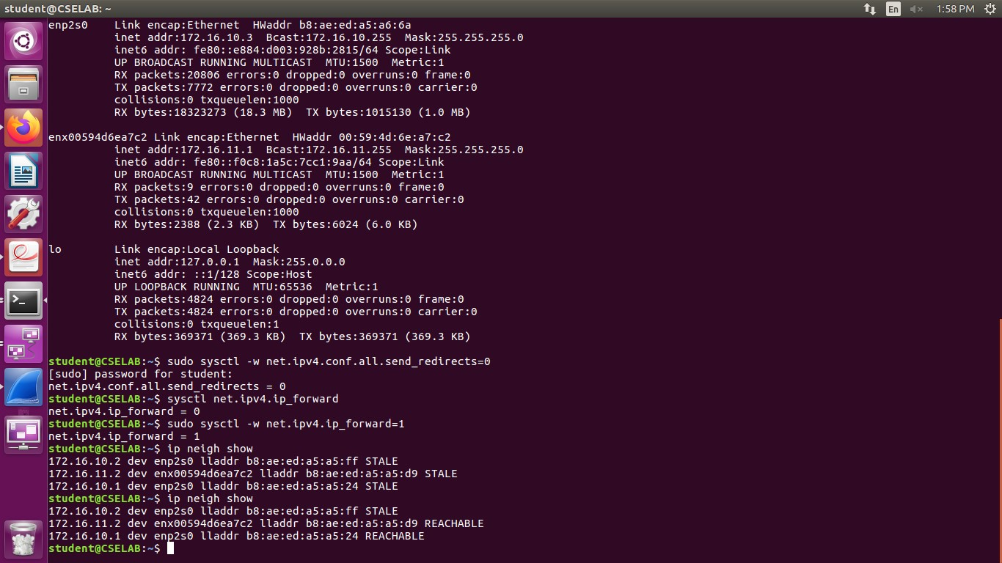

Sending data from Hb to Ha using nc command

At Hb:

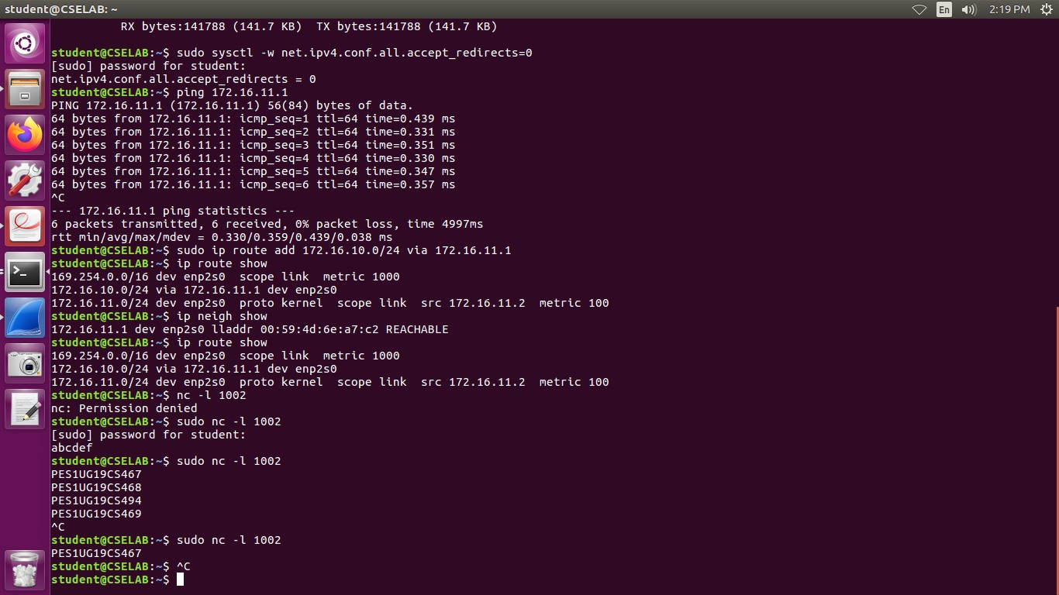

At Ha:

